Overview and Purpose
Tier 1 technical support often needs to verify different aspects of the domain information for a merchant’s store. This includes
- Domain registration
- DNS host and records
- Source of Authority
- Email records
as well as several other pieces of vital information. Unfortunately, this topic is not covered in great depth during Tier 1 technical support training, leaving the technical support team lacking in some of the resources necessary to assist customers.

To that end, this guide serves to provide examples of valuable DNS information resources, where to find them, how to use them, and what each is capable of. A quick reference and process flow chart is included to speed the process along once technical support agents know what they need to.

Tool: WhatsMyDNS

Domain
https://whatsmydns.net/

Purpose
To verify DNS propagation (all records)
To verify DNS content (all records)

Process
Navigate to https://whatsmydns.net/ and input the full host name (ex domain.com or sub.domain.com), then select the correct record type and click the search button.
Switch to other record types as necessary.
The primary thing you want to see is that all information matches what you’re looking for.
The secondary thing is that most of the information has check marks associated with it.
What you are looking for here is consistency, red x marks mostly mean no response. If you get different results for your query, this means it is still propagating.
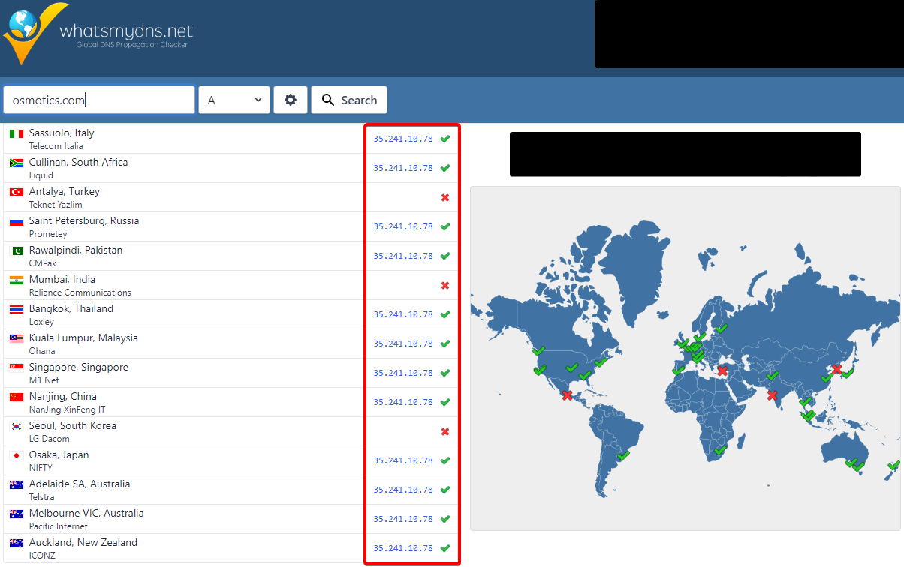

Tool: Who.Is

Domain
https://who.is/

Purpose
To verify DNS reported by the source of authority (SOA)
To verify registrar for domains (even with complex TLDs)
To verify registration status for domains
To verify Nameservers as reported by SOA
To verify network status (Ping and Traceroute)

Process
Navigate to https://who.is/ and type the domain in the box, then click search.
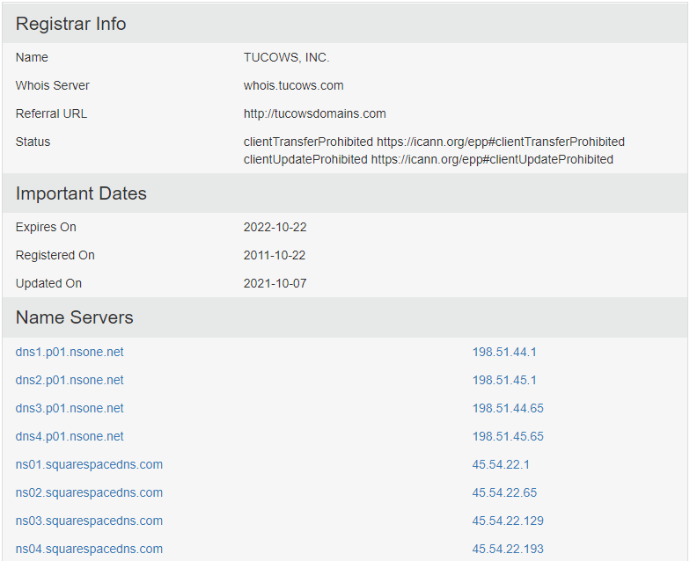
Registrar data only shows the core registrar and not the reseller information.
Important Dates includes
- Expiry
- Update
- Registration
Nameservers are the NS reported by the SOA
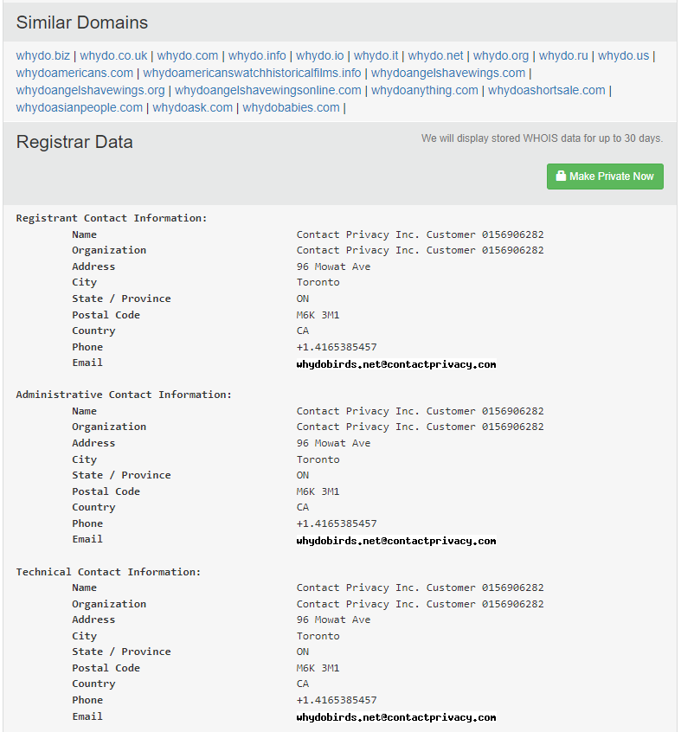
Similar domains are domains with similar names or the same name on different TLDs
Registrar Data reports the contact information for the registrant(s)

To view DNS, switch to the DNS Records tab
DNS info is reported by (and includes) the SOA
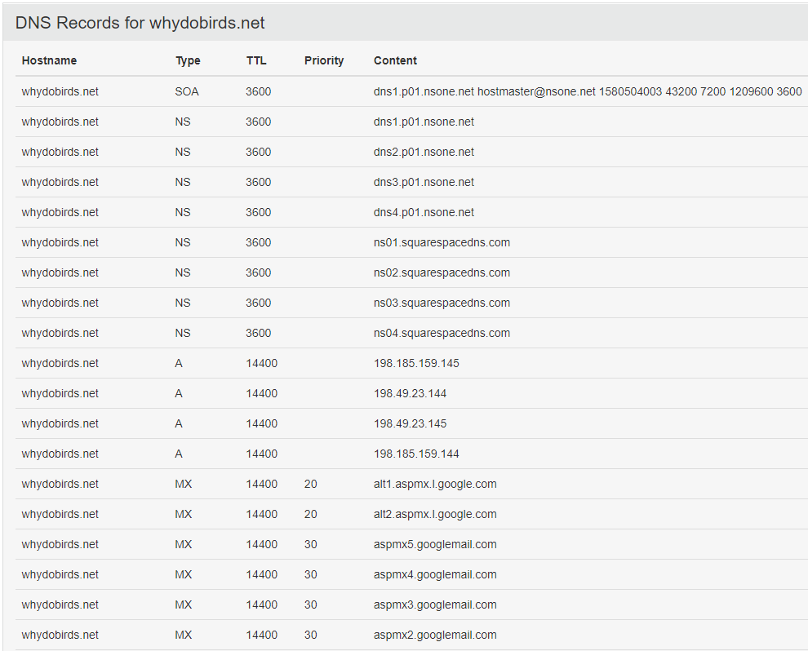

To view network status, switch to the Diagnostics tab
Ping will give the response time for the initial server call.
Traceroute will give the series of systems (by IP address) that were used to access the domain.
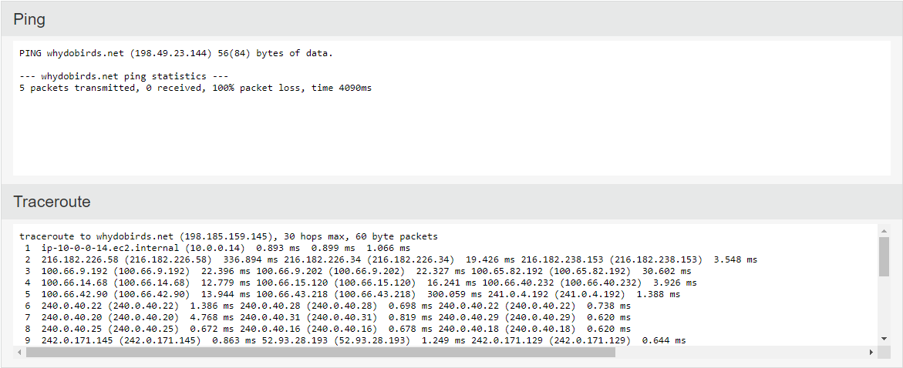

Tool: LeafDNS

Domain
https://leafdns.com/

Purpose
To verify DNS reported by the source of authority (SOA)
To verify Nameservers as reported by SOA and domain registrar
To verify MX records
To verify www resolution (CNAME and A record)

Process
Navigate to https://leafdns.com/ and input the store’s domain with TLD (ex: domain.com) in the box, then click search.
The first two fields that come up will be the nameservers found for the domain. In most cases, this will be the nameservers listed at the current SOA.
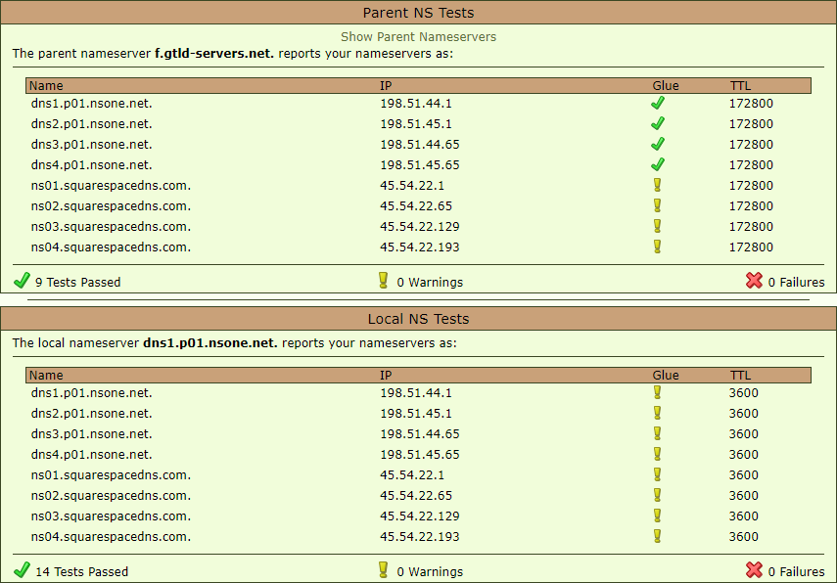
This first box also checks for Non-Authoritative NameServers are typically the result of NS being applied without pointing.
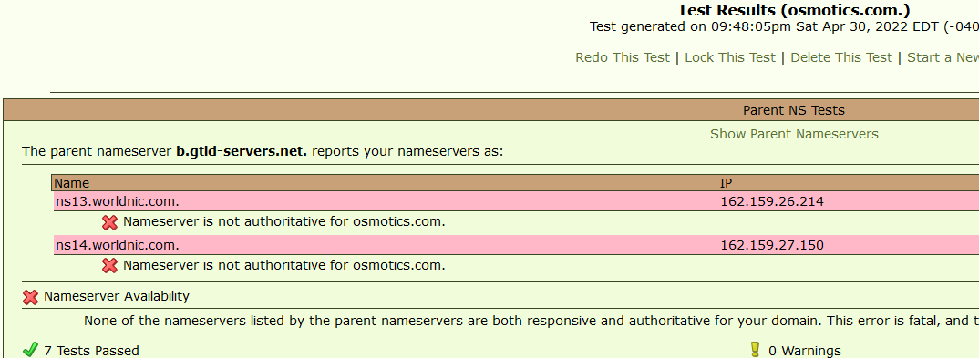
The third field that comes up gives information about the current SOA. This section can usually be ignored.
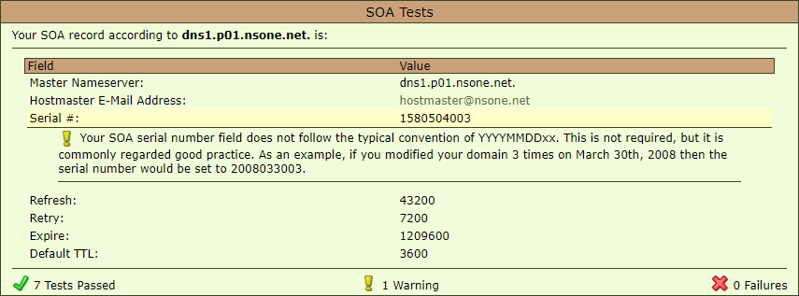
The forth field that comes up will list the current MX information, as reported by the SOA.
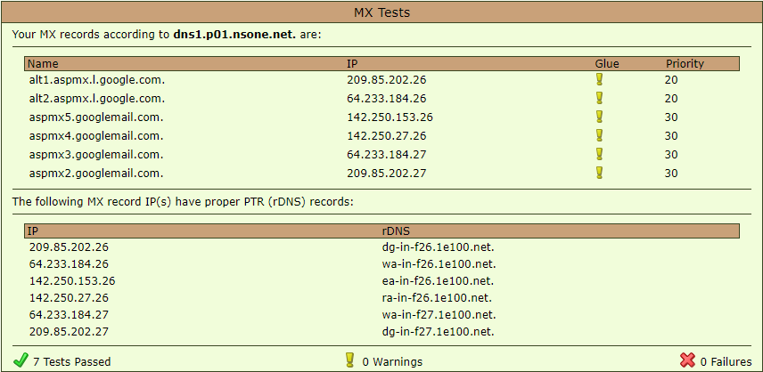
The final field shows the results of a test to resolve www.[domain].
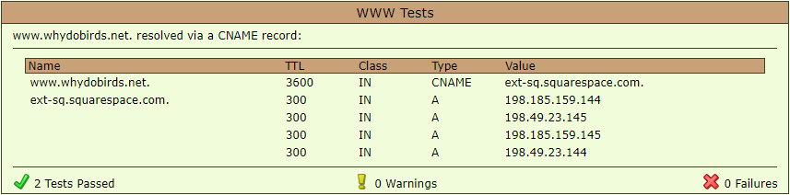

This information is up-to-date within about 5 minutes of the latest update at the SOA or about 10 minutes of an update that changes the SOA.

Tool: ICANN Lookup

Domain
https://lookup.icann.org/

Purpose
To verify Nameservers as reported by domain registrar
To verify the registrar for domains with simple top-level domains (TLD)
To verify the registration status for domains with simple TLDs

Process
Navigate to https://lookup.icann.org/ and type the domain with the TLD in the box, then click the search button.
Do not use a subdomain, as ICANN’s lookup will not return reliable results.
Each important field is labeled clearly.
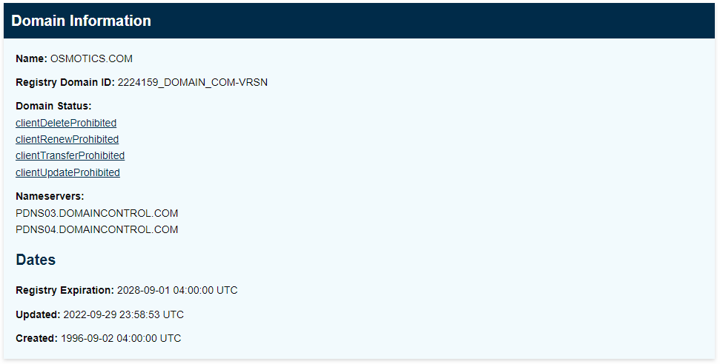
The main thing to be aware of is that some registrars are broader than others, so make sure and check for reseller information when discussing “registrar” information.
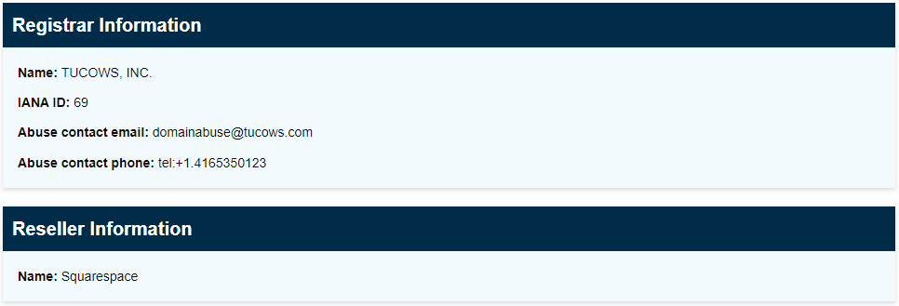

Tool: CentralOps

Domain
https://centralops.net/

Purpose
To verify Nameservers as reported by domain registrar
To verify DNS records as reported by SOA
To verify registrar for domains (even with complex TLDs)
To verify network ownership (IP address management)
To verify registration status for domains

Process
Navigate to https://centralops.net/
Select the specific tool you need. For most purposes, the Domain Dossier is the most useful.

Domain Dossier.
Enter the domain with TLD in the search, then click the search button.
Address Lookup will contain the Canonical name, Aliases, and IP address for the domain.
Domain WhoIs Record will contain information about the registrar, the reseller, and the domain’s registration status.
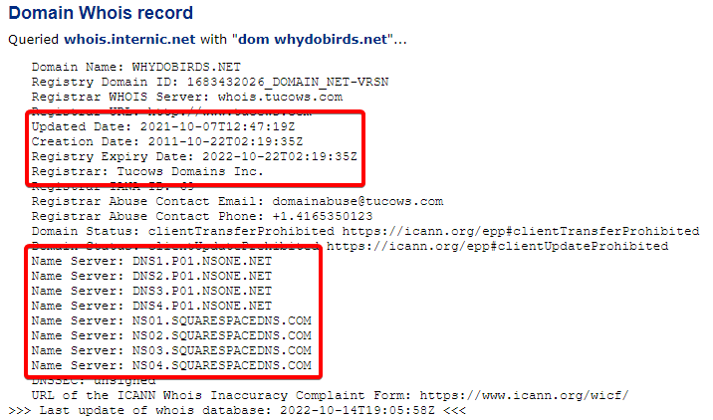
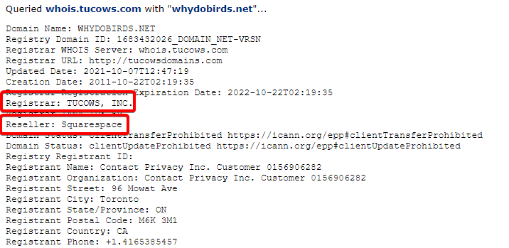
Network WhoIs Record will contain information about the nameserver and SOA data for the domain.
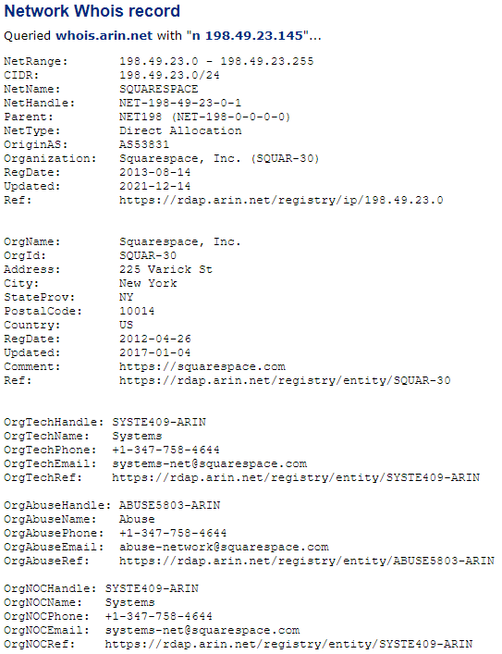
DNS Records contains all records for the domain, including domain forwarding information and subdomain assignment.
This is the most complete DNS checker for SOA info for NON-expired domains. When a domain is expired, most searches will result in limited returns, usually only including the nameserver information.
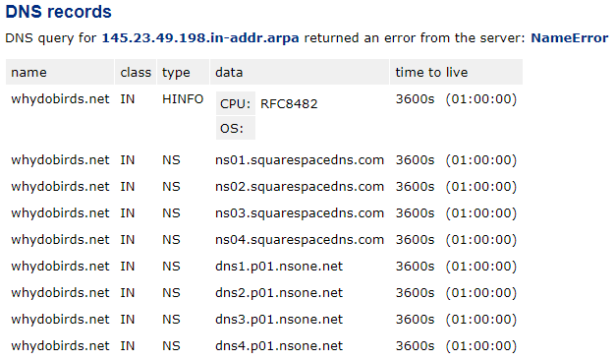

Domain Check.
Enter the domain with TLD in the search, then click the search button.
The results will inform you of the registration data (if registered) and whether the domain is available.
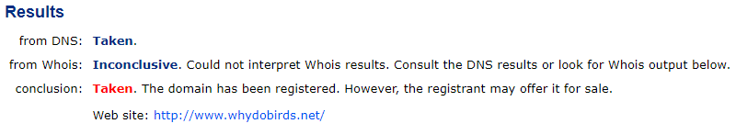
Email Dossier.
Enter the email address in the search, then click the search button.
The results will go over DNS information relevant to the address, whether email is deliverable, and data on the mail server that hosts the address.
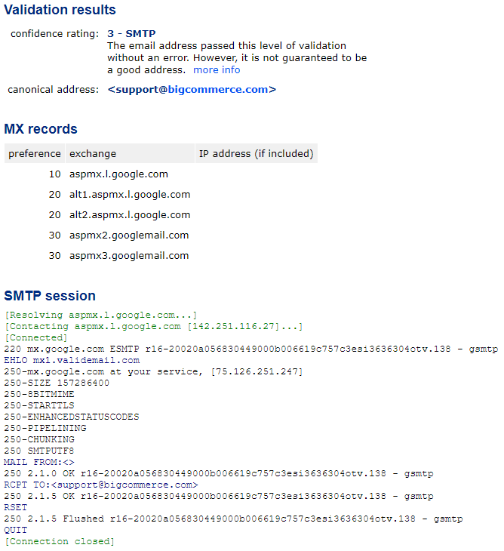

Process: Add/Update MX Records
Generally, do not update merchant DNS information for them without EXPLICIT permission, and be sure to let them know that this is an exception. If DNS is handled incorrectly, it can cause the store to stop functioning correctly.

Verify source of authority (nameservers) using an appropriate tool.
If not BigCommerce, direct merchant to correct source of authority.
If BigCommerce, request accurate records from merchant.
Once you receive records, assist merchant in adding them to the store.

Standard MX record structure has one of the following formats:
- Host Value TTL Priority
- Host Value Priority
- Priority Host Value
- Priority Host Value TTL
Example:
@ mx.zoho.com 10
@ mx2.zoho.com 20
@ mx3.zoho.com 50
The first of which would be entered as
Host: domain.com
Value: mx.zoho.com
Priority: 10

Most MX systems have one more CNAME or A records to be added. They will have one of the following formats:
- Type Host Value TTL
- Type Host Value
- Host Value TTL
Most MX systems will also need an SPF record, which will be joined with the BigCommerce SPF.
Some MX systems will also use DKIM records. DKIM records are typically added as a TXT record. They have the format
Host Value

Related Support Articles from Internal KB
[Out of Date] Third Party MX Records: [Lightning Link]
Troubleshooting SSL Installation: [Lightning Link]
Troubleshooting 3rd Party SSL Installation: [Lightning Link]
Using Command Prompt for DNS lookup: [Lightning Link]

External DNS Resources
- Google DNS support
- GoDaddy DNS support
- Namecheap DNS support
- eNom DNS support
- Domain.com DNS support
- HostGator DNS support
- BlueHost DNS support

(Links may be subject to change. Check for permalinks.)

Useful Links for DNS Reference
- DNS Glossary
- DNS Diagram for our visual folks
- Very cute comic on how DNS works
- Archive of DNS Records - a tool that provides DNS history. You can see what was done with records previously.
- https://youtu.be/9d0iu2Q6iMU
- https://youtu.be/nyH0nYhMW9M

FAQ
- Can I set up a CNAME record and a TXT record for a subdomain at the same time?
  - Not usually. The TXT record will be ignored at the parent domain’s host and often excluded at the CNAME’s target. If a subdomain requires a TXT record, then the subdomain should be pointed with an A record to its target.
- How do I register a subdomain of a domain?
  - There’s no need to register a subdomain if you already own the domain. Simply setting up an A record or a CNAME record makes it so the subdomain exists.

